IN THE HIGH COURT OF JUSTICE Claim No: PT-2025-001017
BUSINESS AND PROPERTY DIVISION
PROPERTY, TRUST AND PROBATE LIST

BETWEEN:

RWE GENERATION UK PLC
(Company registration number 3892782)

Claimant
and

- PERSONS UNKNOWN WHO WITHOUT THE CLAIMANT’S PERMISSION ENTER OR REMAIN UPON THE PREMISES DESCRIBED IN THE CLAIM FORM, OR WHO DAMAGE OR DEFACE ANY OF THOSE PREMISES OR ANY PART OF THEM, FOR THE PURPOSES OF PROTEST WHETHER IN SUPPORT OF ANY GREENPEACE CAMPAIGN OR OTHERWISE.

- GREENPEACE UK LIMITED
(Company registration number 02463348)

- GREENPEACE LIMITED
(Company registration number 01314381)

Defendants
_________________________________________________
[DRAFT] ORDER
_________________________________________________

PENAL NOTICE

IF YOU THE WITHIN DEFENDANTS OR PERSONS UNKNOWN OR ANY OF YOU DISOBEY THIS ORDER OR INSTRUCT OTHERS TO BREACH THIS ORDER YOU MAY BE HELD TO BE IN CONTEMPT OF COURT AND MAY BE IMPRISONED, FINED OR HAVE YOUR ASSETS SEIZED.
ANY OTHER PERSON WHO KNOWS OF THIS ORDER AND DOES ANYTHING WHICH HELPS OR PERMITS A DEFENDANT TO BREACH THE TERMS OF THIS ORDER MAY ALSO BE HELD IN CONTEMPT OF COURT AND MAY BE IMPRISONED, FINED OR HAVE THEIR ASSETS SEIZED.

IMPORTANT NOTICE TO THE DEFENDANTS AND PERSONS UNKNOWN
This Order prohibits you from doing the acts set out in this Order. You should read it carefully. You are advised to consult a solicitor as soon as possible. You have the right to ask the Court to vary or discharge this Order.
BEFORE on October 2026
UPON the Claimants having issued this Claim by a Claim Form dated 1 October 2025
AND UPON injunctive relief against the First Defendant having been granted by the Honourable Mr Justice Trower on 24 October 2025 ("the Injunction Order") (enclosed at Schedule 1)
AND UPON the Claimant having applied for a review of the Injunction Order by application notice dated 17 July 2026
AND UPON the first annual review of the injunctive relief having taken place on [ ] October 2026
AND UPON READING the Witness Statements of Rachel Jane Smith dated 1 October 2025, William Henry Jeffery dated 1 October 2025 and 1 October 2026, and Donal Patrick Kelly dated 20 October 2025 and 1 October 2026
AND UPON HEARING [ ] for the Claimant [and for the Defendants] [there being no other attendance]
AND UPON the Court being satisfied that there has been no material change in circumstances warranting amendments to or the setting aside of the injunctive relief granted by the Injunction Order

IT IS ORDERED THAT:
- The Injunction Order shall remain in full force and effect, subject to the amendments thereto set out in Schedule 2 to this Order and subject to review as provided for at paragraph 3 of the Injunction Order.

- The Court will provide sealed copies of this Order to the Claimant’s solicitors for service and notification by the steps set out in paragraphs 5(i)-(ii), 10, 11 and 13 of the Injunction Order.

Dated: 2026

SCHEDULE 1 – THE INJUNCTION ORDER

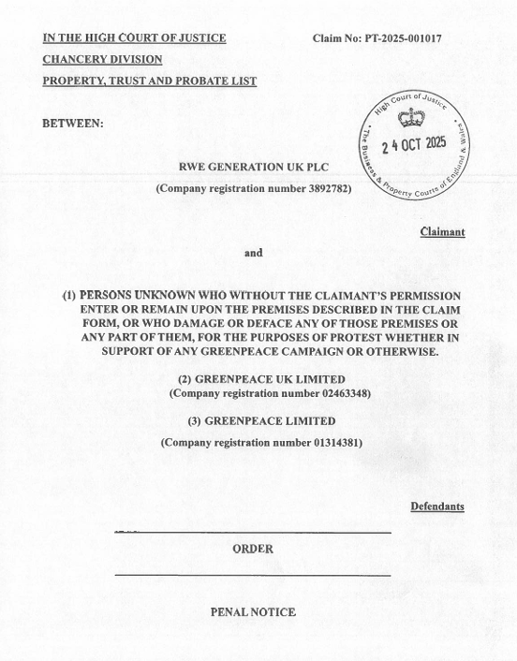

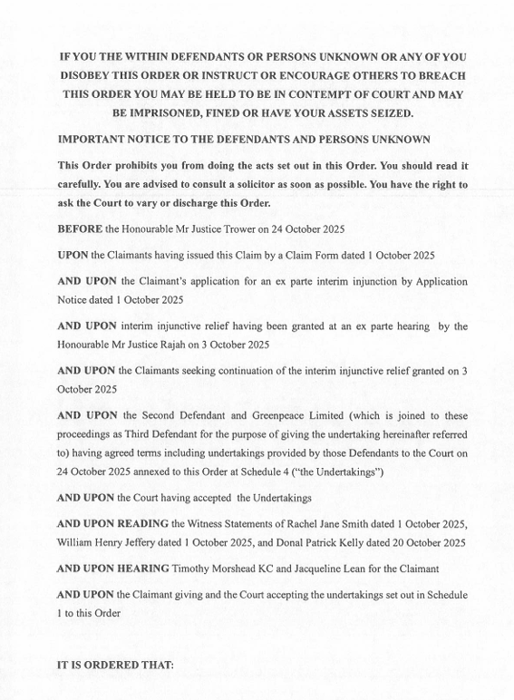

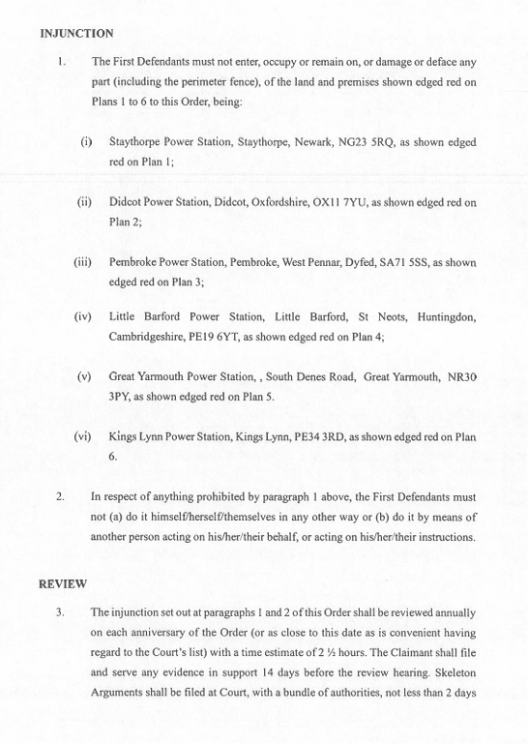

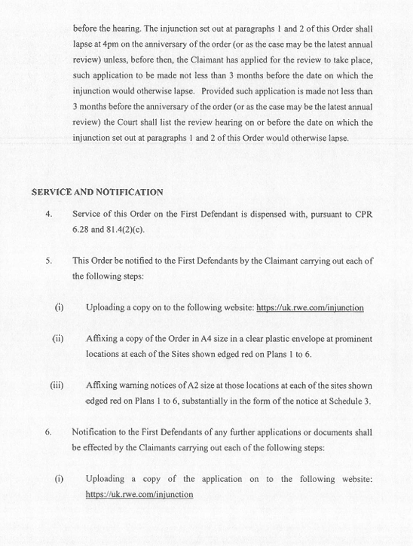

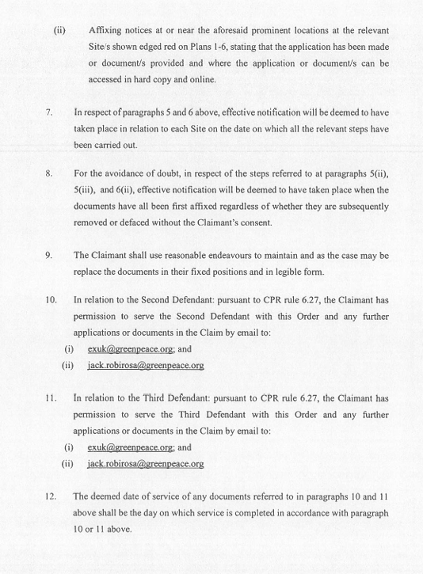

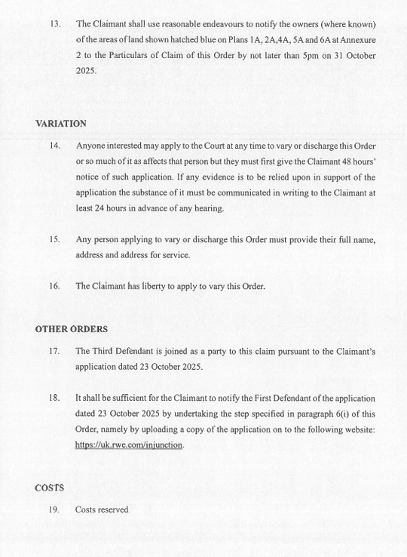

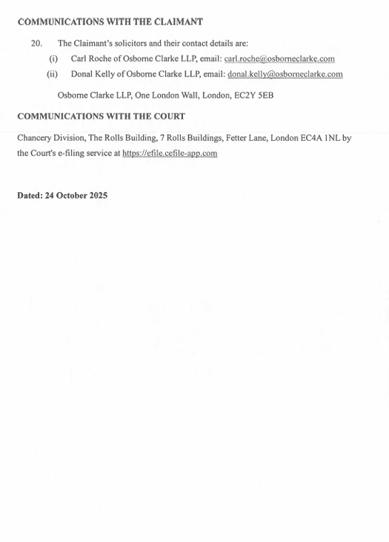

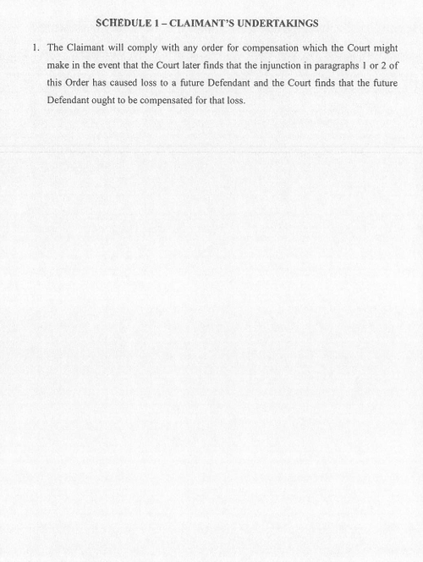


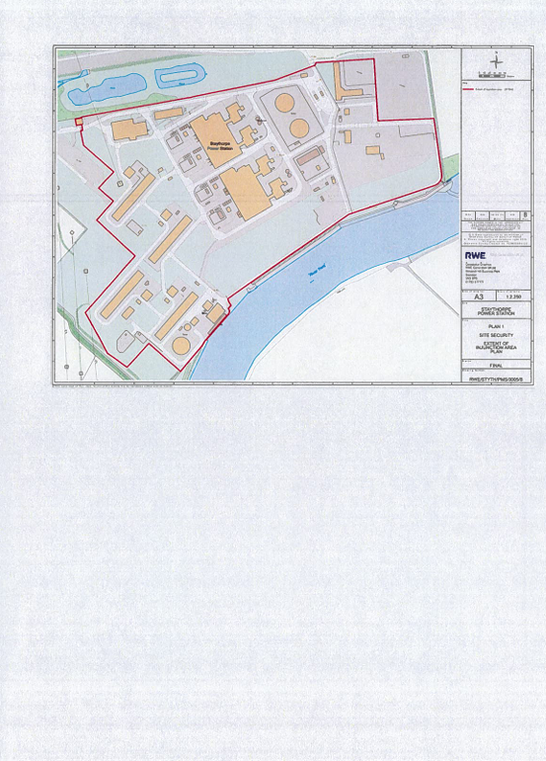

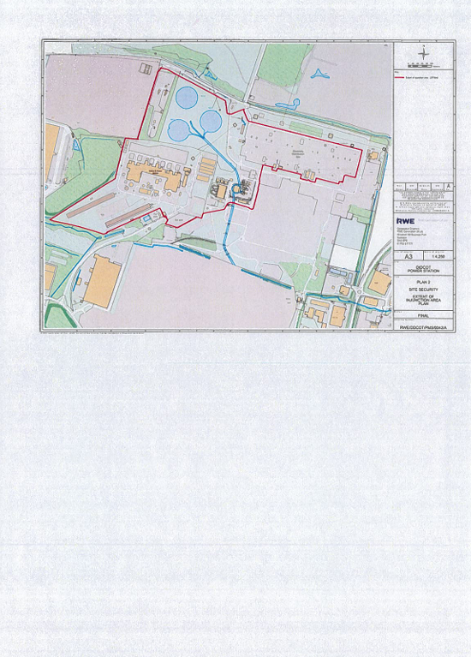

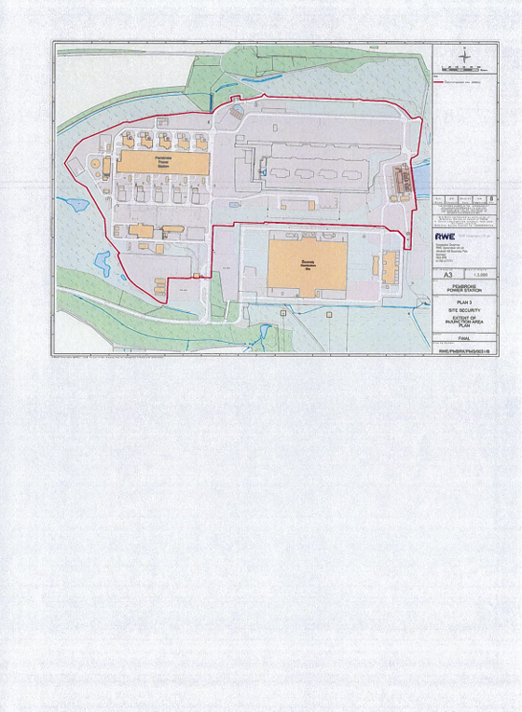

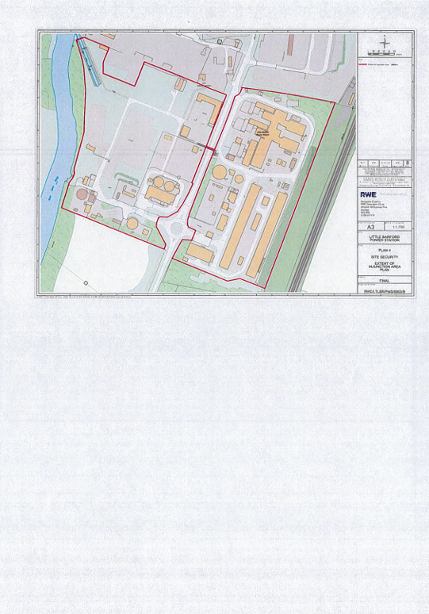

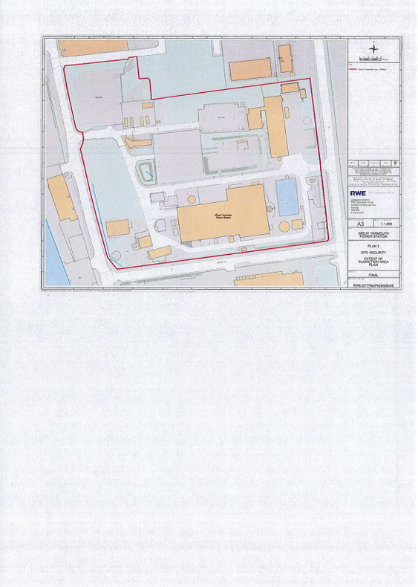
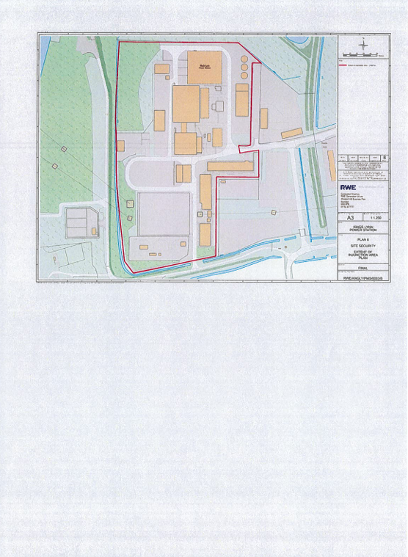

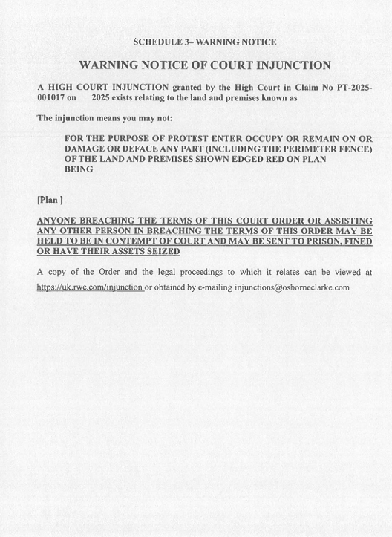


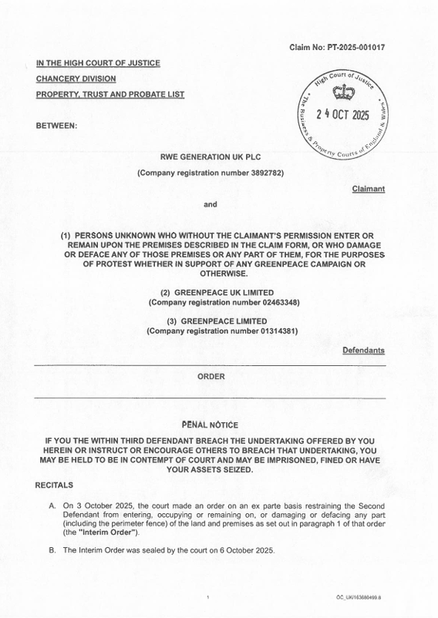
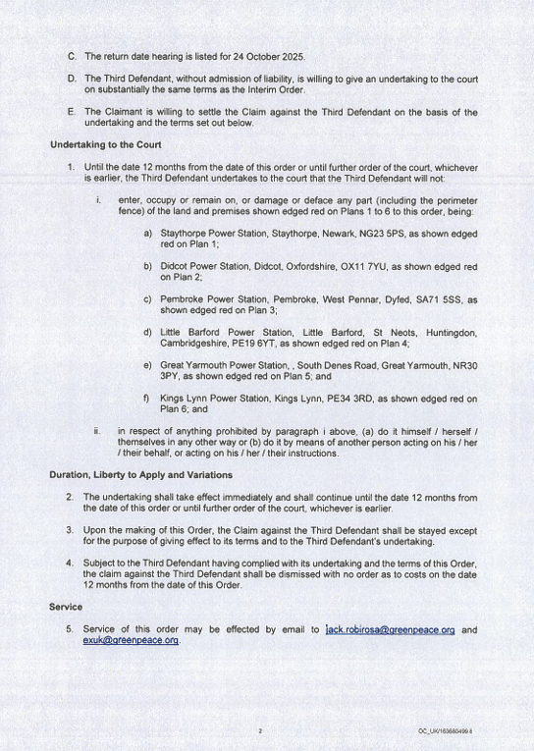
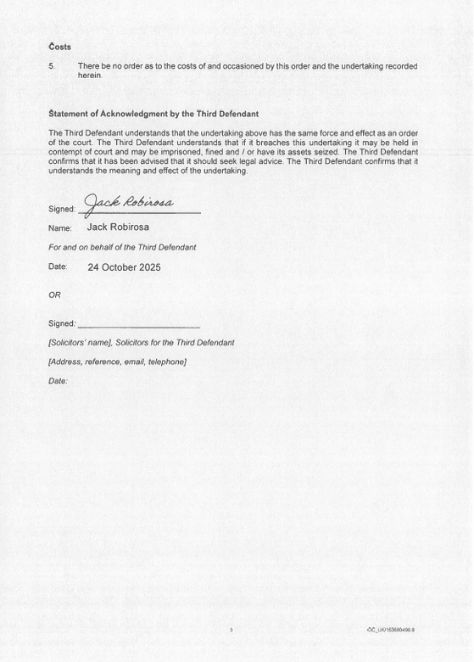

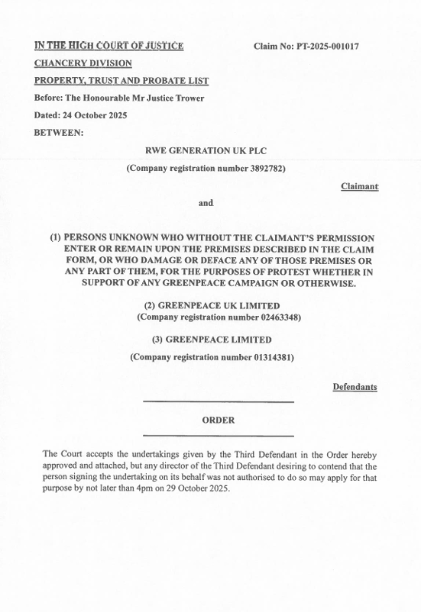
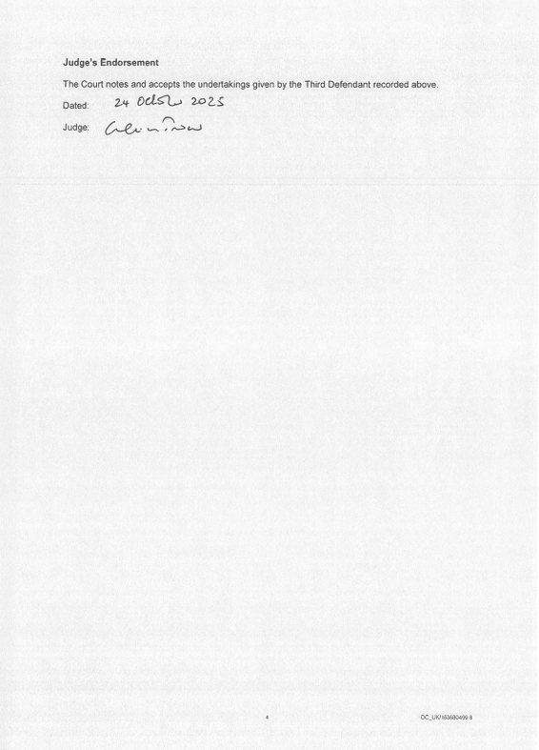

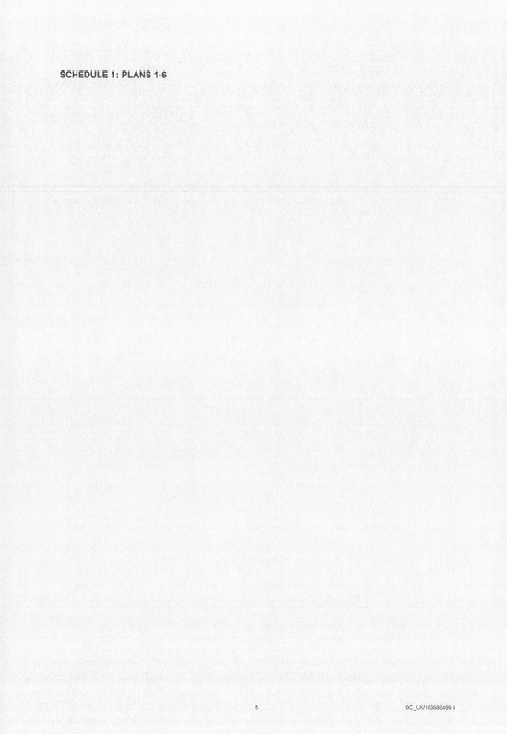
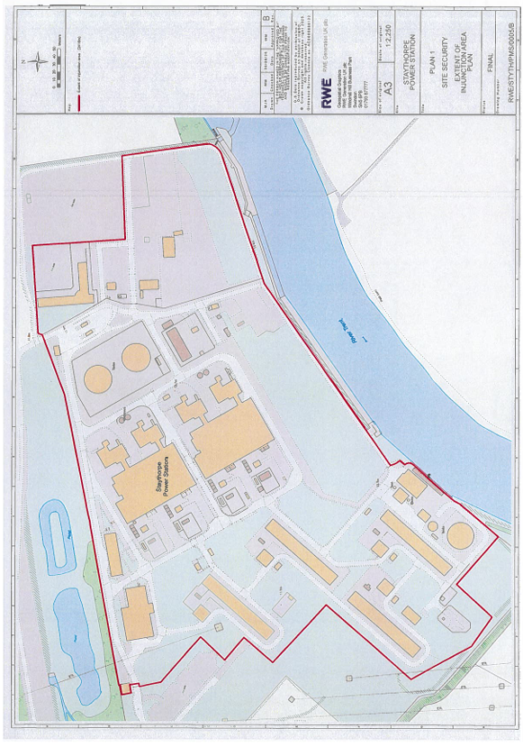
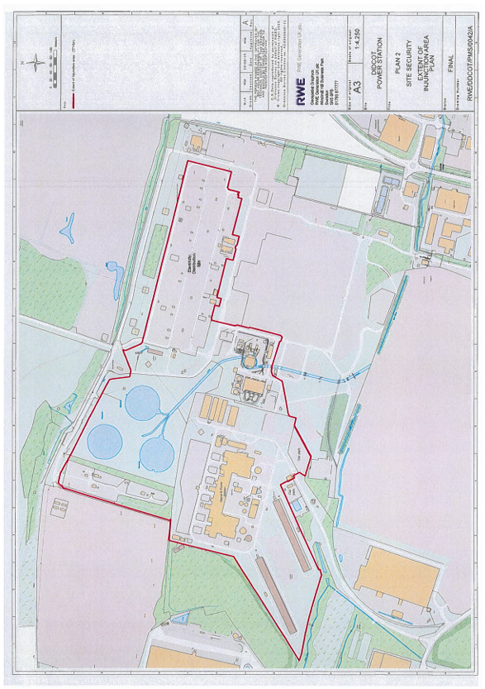

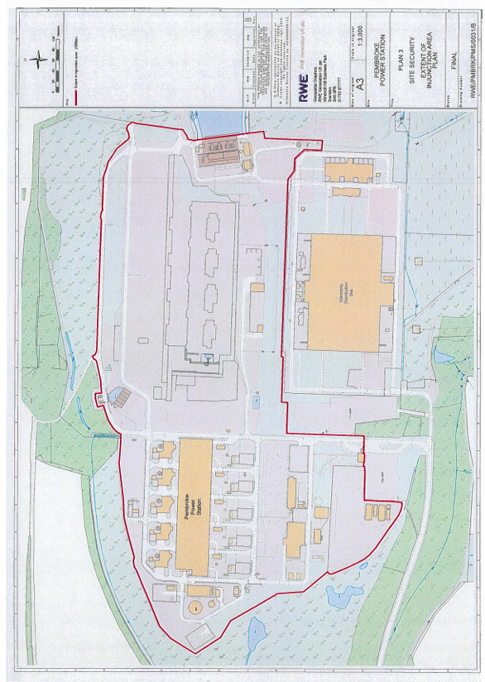
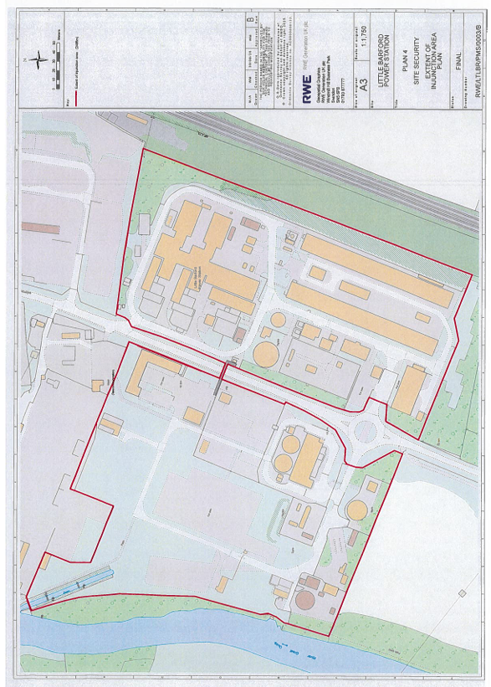

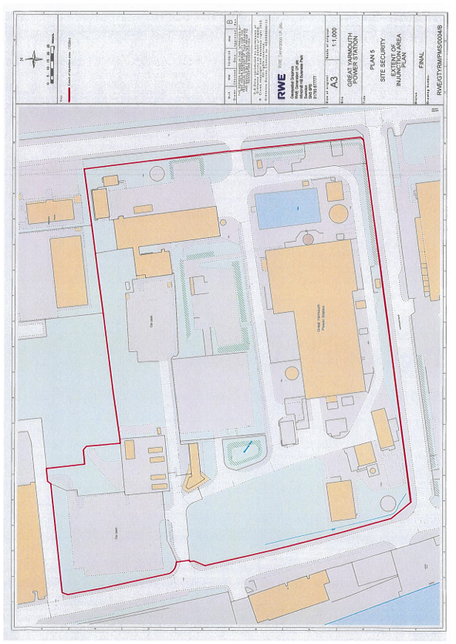
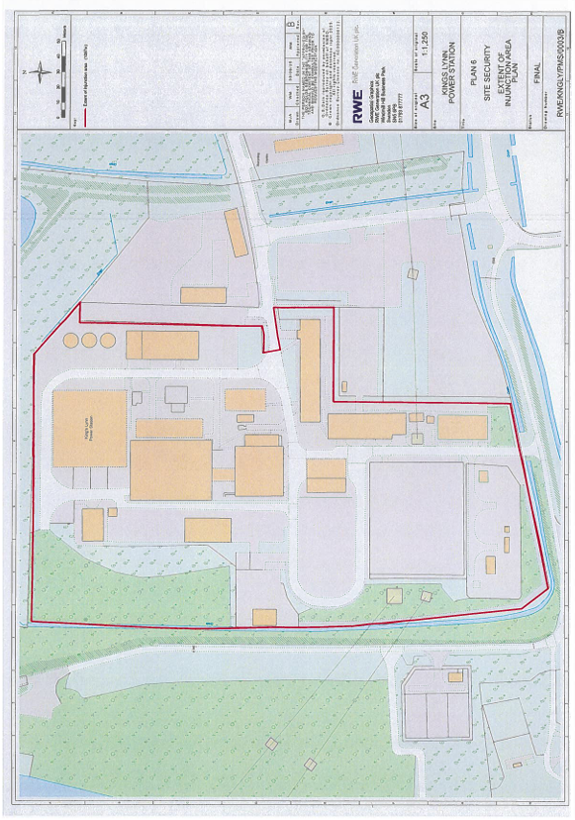
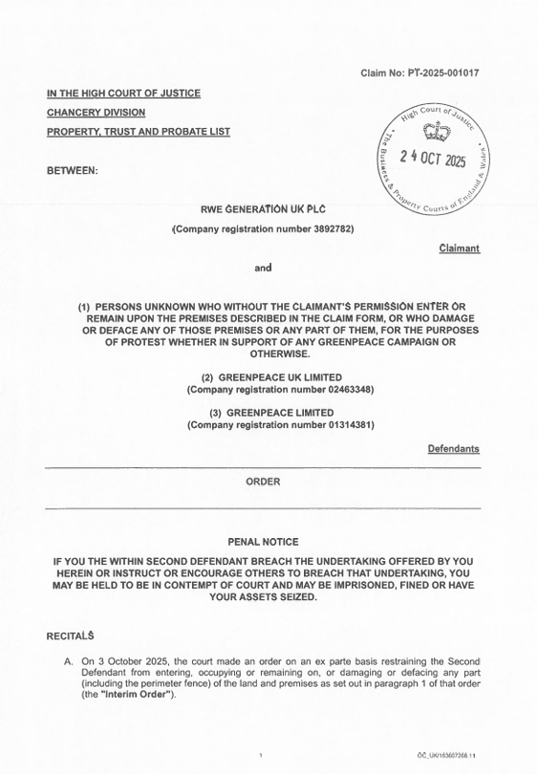
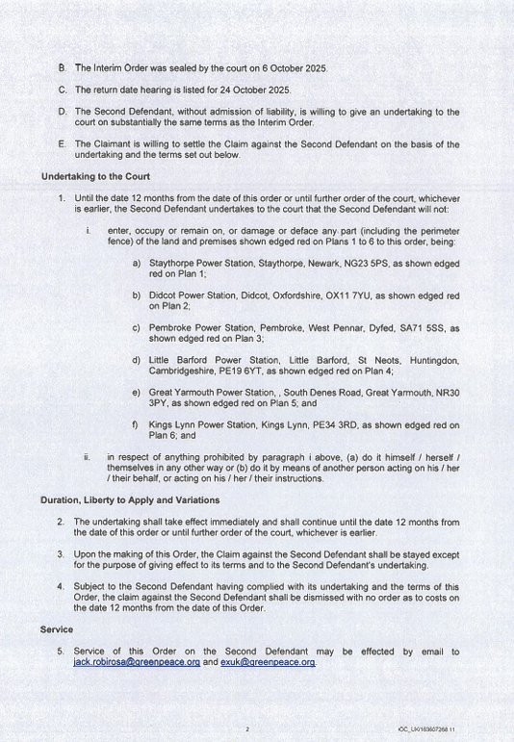
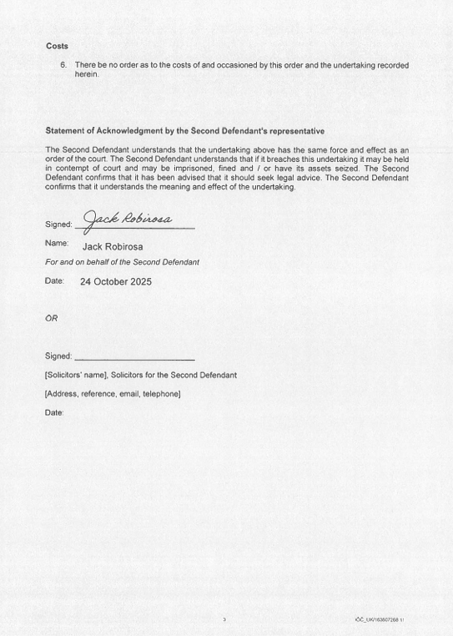
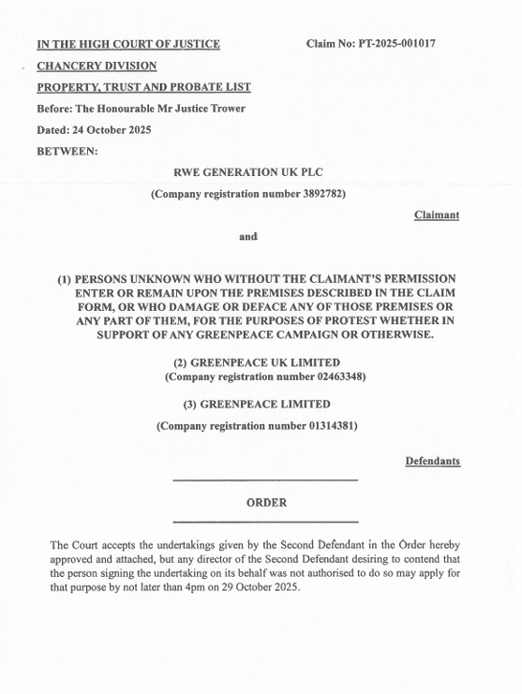

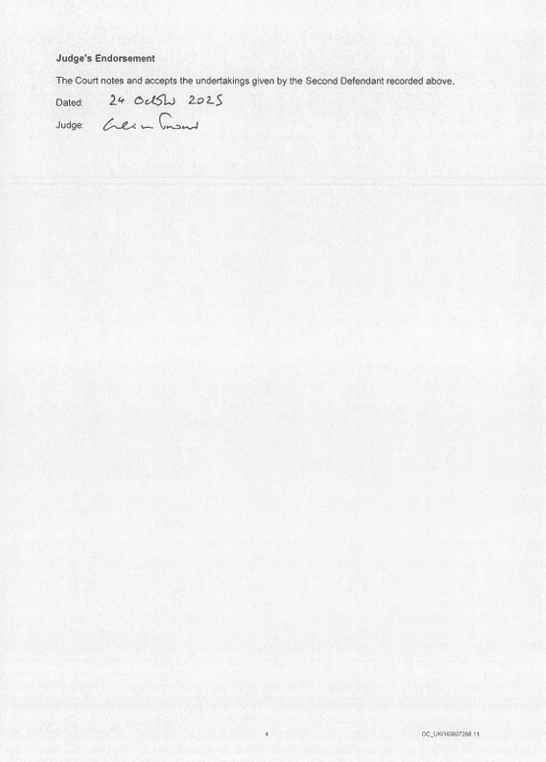

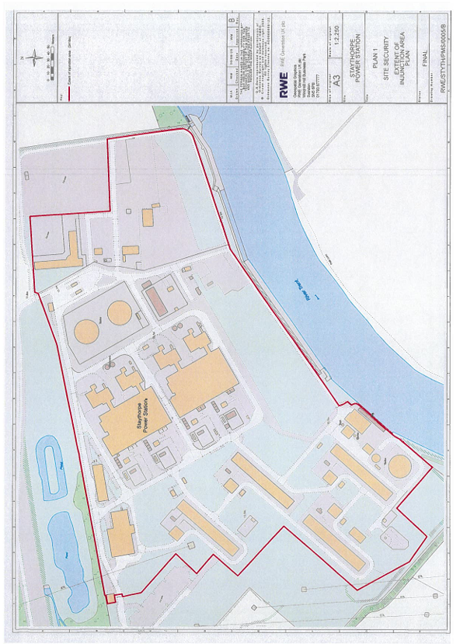

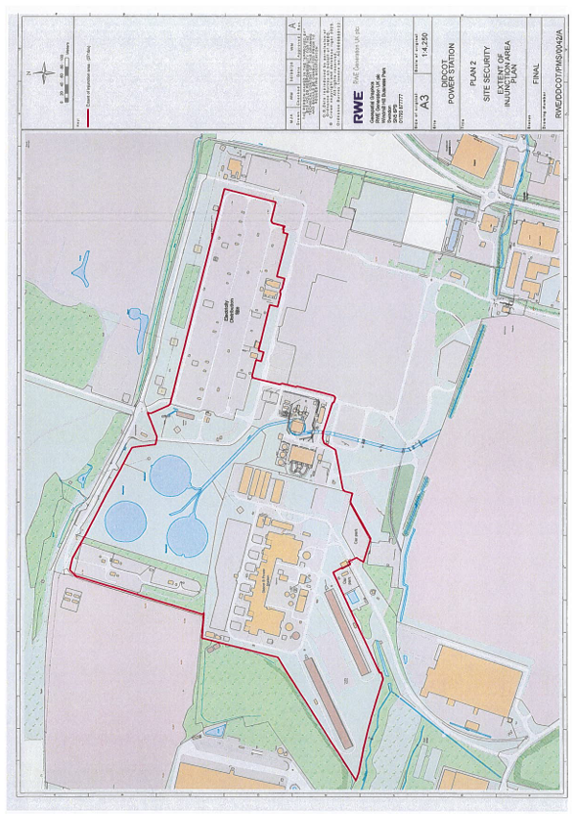
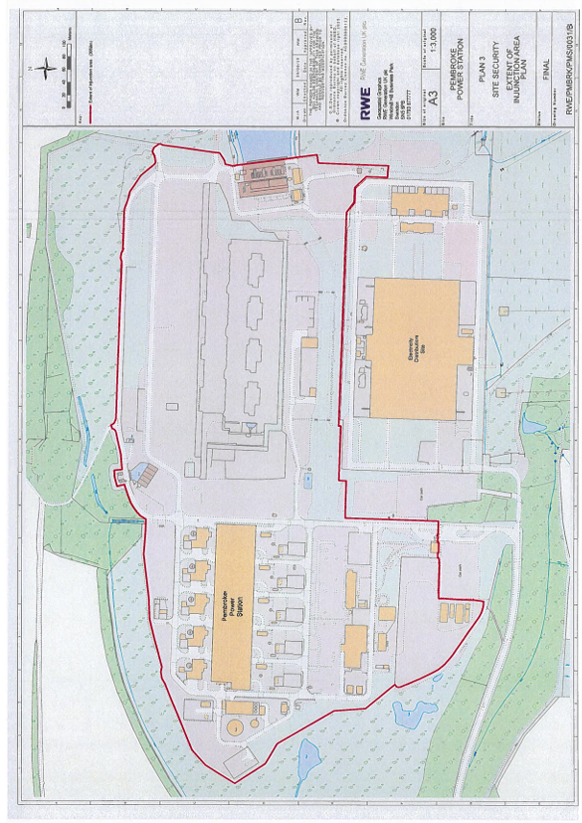

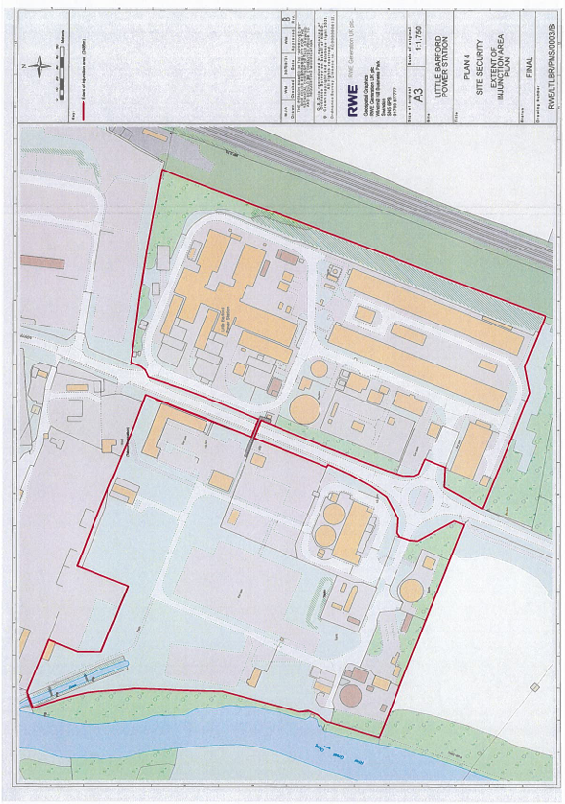
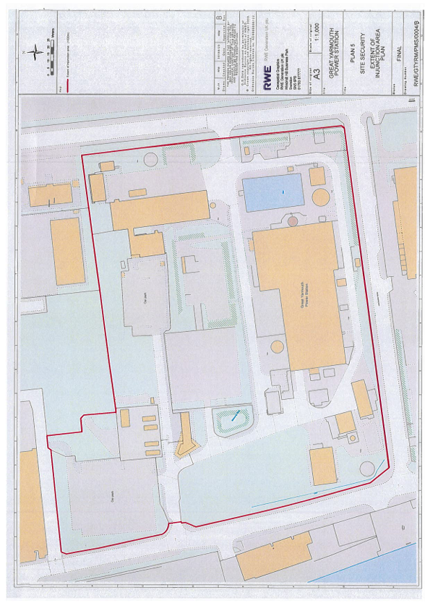
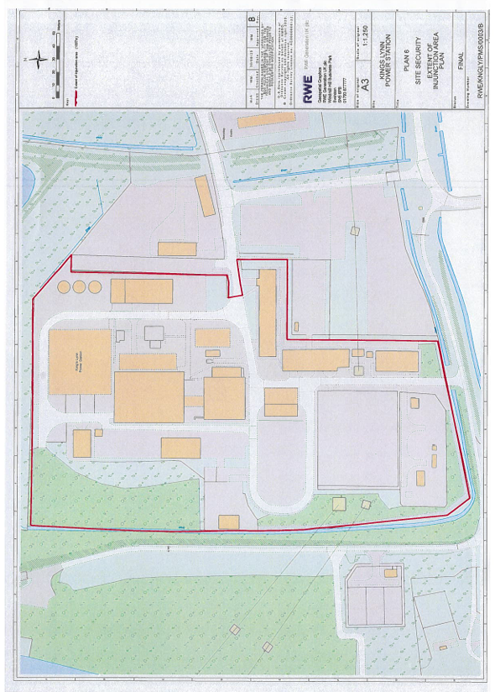

SCHEDULE 2
- Paragraph 10 of the Injunction Order shall be read as follows:

In relation to the Second Defendant: pursuant to CPR rule 6.27, the Claimant has
permission to serve the Second Defendant with this Order and any further
applications or documents in the Claim, insofar as the Claim is continuing as against the Second Defendant, by email to:
(i) exuk@greenpeace.org; and
(ii) jack.robirosa@greenpeace.org

- Paragraph 11 of the Injunction Order shall be read as follows:

In relation to the Third Defendant: pursuant to CPR rule 6.27, the Claimant has
permission to serve the Third Defendant with this Order and any further
applications or documents in the Claim, insofar as the Claim is continuing as against the Third Defendant, by email to:
(i) exuk@greenpeace.org; and
(ii) jack.robirosa@greenpeace.org

